

FRENCH ORAL STAGE 2 SAMPLE EXAMINATION

Section 7 of the New WACE Manual: General Information 2006–2009 outlines the policy on WACE examinations.

Further information about the WACE Examinations policy can be accessed from the Curriculum Council website at http://newwace.curriculum.wa.edu.au/pages/about_wace_manual.asp.

The purpose for providing a sample examination is to provide teachers with an example of how the course will be examined. Further finetuning will be made to this sample in 2008 by the examination panel following consultation with teachers, measurement specialists and advice from the Assessment, Review and Moderation (ARM) panel.

0000.doc



Western Australian Certificate of Education, Sample External Examination

Preparation Booklet

FRENCH
Please place your student identification label in this box
ORAL PAPER
STAGE 2

Student Number: In figures

In words

Time allowed for this oral examination
Reading/planning time: 15 minutes
Oral examination: 15 minutes

Materials required/recommended for this paper

To be provided by the supervisor
Preparation booklet, paper

To be provided by the candidate
Standard items: Pens, pencil, eraser or correction fluid, highlighter, ruler

Important note to candidates
No other items may be taken into the examination room. It is your responsibility to ensure that you do not have any unauthorised notes or other items of a non-personal nature in the examination room. If you have any unauthorised material with you, hand it to the supervisor before reading any further.

Structure of this oral examination

Sections | Time  allocation |  | Marks available
Preparation | 15 minutes |  | N/A
Prompted dialogue | 2-3 minutes |  | 5
Stimulus text | 2-3 minutes |  | 5
Interview | 8-9 minutes |  | 20
 |  | Total marks | 30

Instructions to candidates
1. The rules for the conduct of Curriculum Council examinations are detailed in the Student Information Handbook. Sitting this examination implies that you agree to abide by these rules.
2. The total time allocated for the oral examination is 30 minutes (15 minutes preparation, 15 minutes interview). This time includes 3 minutes for the reconciliation of marks by the examiners.
3. During preparation time, you will prepare responses to the stimulus materials and make notes, as required.
4. Notes made during the preparation time must be handed to the examiner and may not be used during the interview.
5. Instructions for each section of the oral examination are given in this preparation booklet.

STIMULUS TEXTS

Print text 1: Holidays
Brief: Vous avez reçu un mél de votre amie Nathalie, qui a passé quelques jours chez son cousin Alain en Belgique. Racontez ce qu’elle vous a écrit dans son mél.
You have received an email from your friend, Natalie, who has spent some days with her Belgian cousin, Alain. Talk about what she wrote in her email to you.
NB : Use the following pictures as a guide for what you talk about.

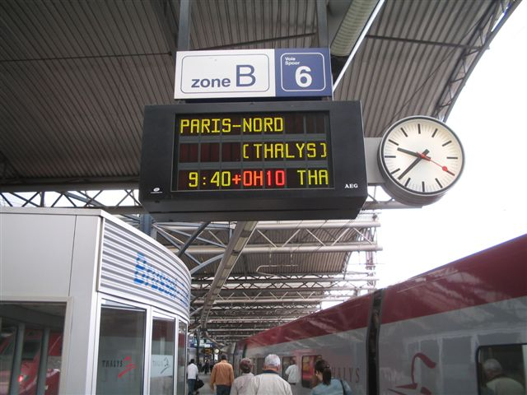
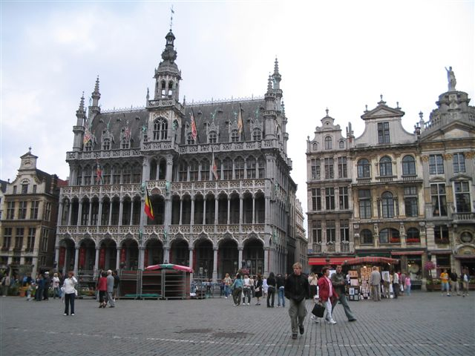
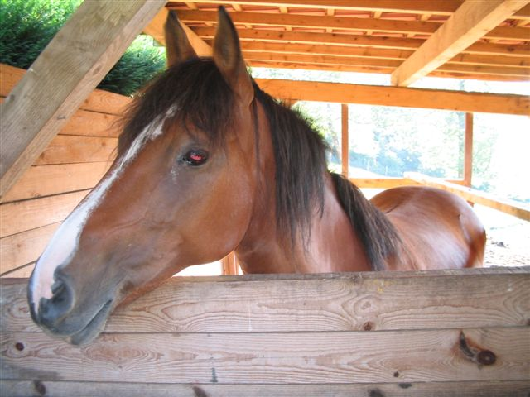
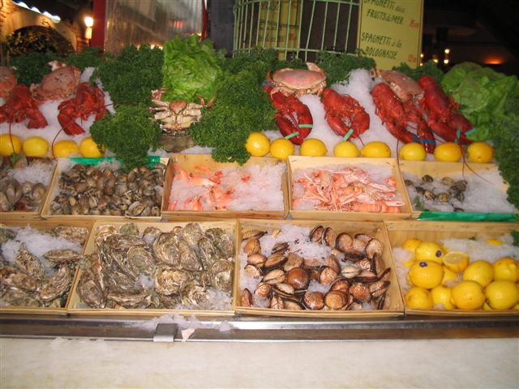

For copyright reasons these images cannot be reproduced in the online version of this document.
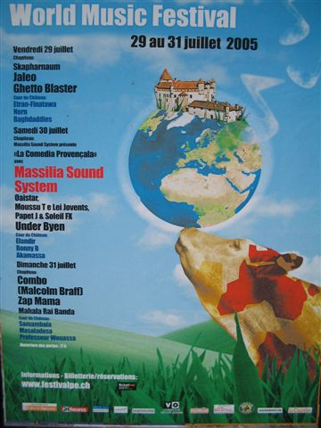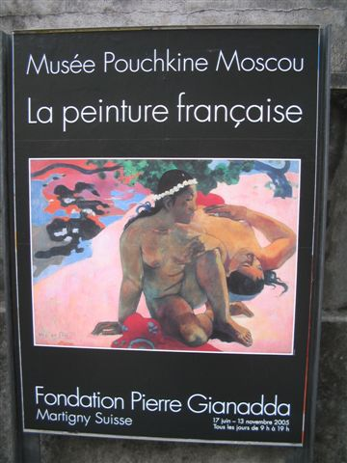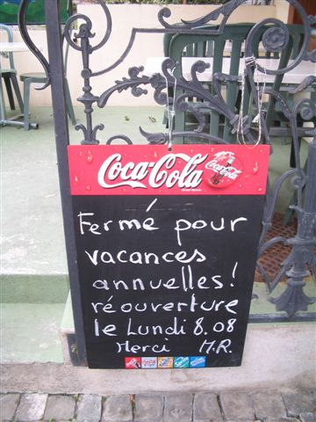
[World Music Festival image from: Bureau du Festival, 2005 ; other photographs from: H. Rekelhof]
Print text 2: Sport

Brief: Les Australiens adorent le sport. Les Français, qu’est-ce qu’ils aiment?
Australians reputedly love sport. What do you think French people are passionate about?

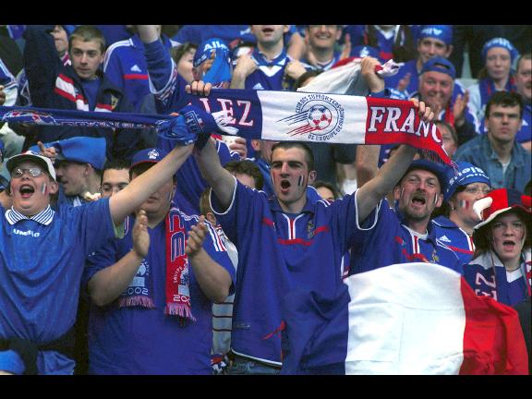
[From: Stefan & Ministère des Affaires Étrangères, 2003]

Prompt bag: Travel

À l’hôtel

Vous vous appelez Dominique Duval et vous habitez à 23 Rue de Champagne. Votre numéro de téléphone est le 93 78 156 07. Vous êtes né(e) le 18 octobre 1983. Vous avez 2 enfants.

In bag is also a pretend Carte Bancaire.

(This may be changed to pretend cheque or pretend euros after use, so the next candidate will have a slight alteration.)

Students will not have this form during preparation. The examiner, who will be the hotel clerk, will fill in the form below according to the candidate’s responses. “Épelez-ça…”

Réservation de chambre

Nom: ___________________________________________________

Prénom: ___________________________________________________

Adresse: ___________________________________________________

Tél: ___________________________________________________

Date de naissance: __________________________________________

Combien de personnes: ________________________

Combien de chambres: ________________________

Avec salle de bains: __________________________________________

Petit déjeuner: ______________________________________________

Heure: ____________________________________________________

Paiement: cheque / carte bancaire / euros ________________________

Prompt bag: Food

Au Café

Vous avez faim et soif. Vous vous arrêtez au café pour une demi-heure. Commandez ce qu’il y a dans les images. Assurez-vous que vous avez assez d’argent.

The Candidate has several pictures of food and drink, a menu and some pretend euros.

Examiner will be the waiter/ess. S/he will say some items which have been ordered are unavailable.

Rubric

Order
Stilted language Fluent language

1 2 3 4 5

Inaccurate Accurate

1 2 3 4 5

Not spontaneous Spontaneous

1 2 3 4 5

Intercultural (Tip)

Prompt bag: School life

Au collège

Vous allez à cette école. Vous avez un(e) corréspondant(e) avec vous, et vous allez expliquer ce qui va se passer à l’école aujourd’hui.

Candidate to have in bag an Australian school timetable and map of school, and picture of students in school uniform.

Examiner to take the part of the exchange student and ask questions, like…Qu’est-ce qu’on fait après la récréation? Mais, on n’a qu’une demi-heure pour le déjeuner! Et on va où pour la biologie?

Rubric

Vocabulary
Mostly incorrect Mostly correct

1 2 3 4 5

Grammar
Mainly inaccurate Mainly correct

1 2 3 4 5

Directions
Mainly inaccurate Mainly correct

1 2 3 4 5

Intercultural:
(lunch, going home, length of school day, uniform etc.)

END OF PAPER
ACKNOWLEDGEMENTS

Print text 1 World Music Festival image from: Bureau du Festival. (2005). Oron World Music Festival [Poster]. Oron, Switzerland: Author.
Published by the Curriculum Council of Western Australia
27 Walters Drive
OSBORNE PARK WA 6017

Other photographs by kind permission H. Rekelhof.

Print text 2 Stefan, C., & Ministère des Affaires Étrangères. (2003). Friendly football match between France and Belgium at the Stade de France in Saint Denis: France fans [Photograph]. In Ministère des Affaires Étrangères, Images de France (3rd ed.). Paris: Author.

